Arduino® Multi-process for FPGA
Have you dreamed of using the huge processing power of FPGAs? Wait no longer!
With the psC language, you will use your Arduino programming skills to program FPGAs.

Run each task on his own processor
You can use 100's and more processors and harness the FPGA computing power.
As shown below, tasks in an Arduino program are running sequentially inside a loop. In a psC program, tasks are running in parallel in their own processor. For example, a task could interface with the console while other tasks could process audio, perform image processing or control robot motors, all without interfering with each other.
This is the ideal machine for embedded systems.
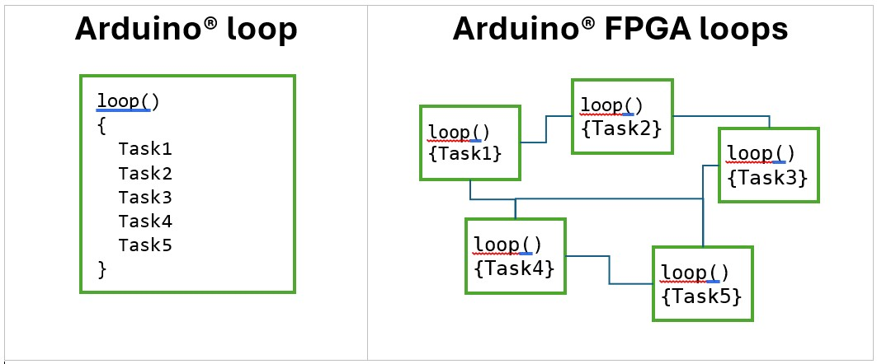

A High-Performance Compiler
The compiler creates a highly optimized tiny custom like processor, without program memory or ALU. The processor still has a Program Counter and supports function call. Each instruction is directly coded in VHDL. Synchronous communication is very efficient and is based on simple values and events. Programming is as simple as Arduino programming. As discussed above, the Arduino loop is broken down for execution on multiple processors. In addition, most DSP algorithms (audio, FFT, image) can be almost directly coded on this processor.

Nearly Identical Code
The psC language is not an HDL – Hardware Description Language, like VHDL or Verilog. The psC language is the first general purpose sequential language for FPGFA programming. The table below shows that the psC code for a counter is nearly identical to the C++ code.
Arduino® Code in C++  enum Cmd_t  { cReset, cUp, cDown, cLoad };  void setup()  {  Value = 0;  }  void loop()  {  switch(iCmd)  {  case cReset:  Value = 0b;  break;  case cUp:  Value++;  break;  case cDown:  Value--;  break;  case cLoad:  Value = NewValue;  };  }; // Infinite loop | Code for FPGA in psC  enum Cmd_t  { cReset, cUp, cDown, cLoad };  setup()  {  Value = 0;  }  loop()  {  switch(iCmd)  {  case cReset:  Value = 0b;  break;  case cUp:  Value++;  break;  case cDown:  Value--;  break;  case cLoad:  Value = NewValue;  };  }; // Infinite loop

